**Sampling Techniques**

1. **Simple random sample**
2. **Stratified Sample**
3. **Systematic sample**
4. **Cluster Sampling**
5. **Convenience Sampling**

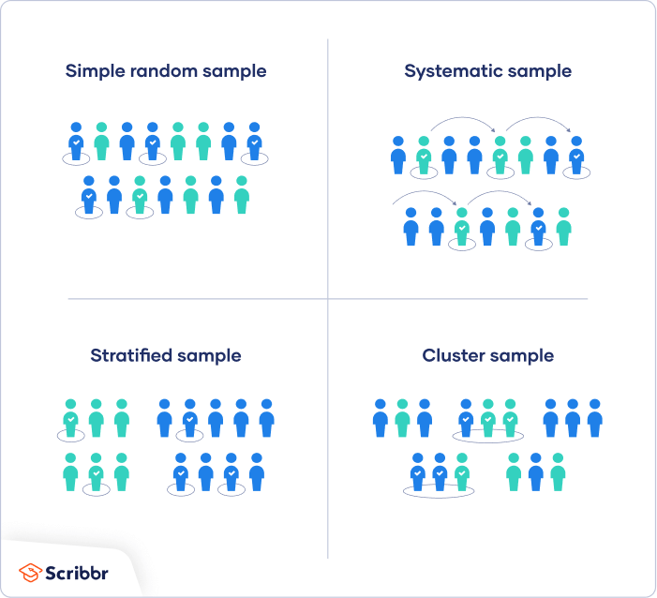

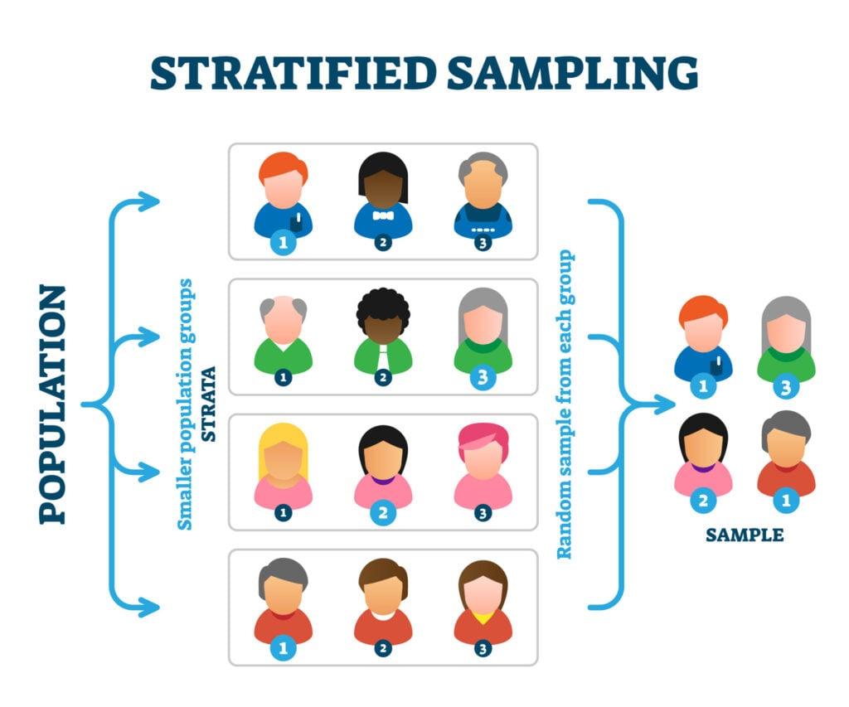

**Systematic sample**

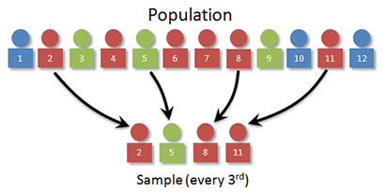

**Cluster Sampling**

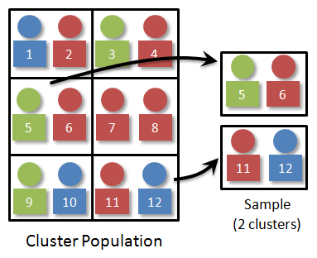

**Convenience Sampling**

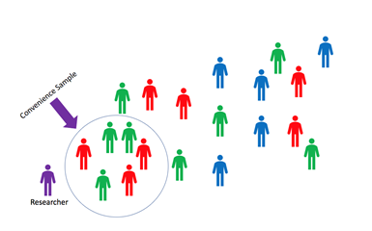

**Exercise:**

If I want to make a sample representing the class, how should I do it.

1. Simple random sample from 24 students.

* Numbering all the students from 1 to 24
* Use a computer to generate a set of 10 random numbers from 1 to 24.

1. Systematic Sample

* Numbering all the students from 1 to 24
* Define a sequence of numbers for the sample, for example: 1, 4, 7, 10, 13, 16, 19, 22 or (1, 5, 9, 13, 17, 21)

1. Stratified sample:

* Divide the population by groups,   
    
  for example: divide the class by majors: business (15) and non-non-business major (9).
* Simple Random Sample from each group. For example: choose randomly 5 from business and 3 from non-business major.

1. Cluster sample

* Cluster/group the sample into several clusters/groups.
* Select a few clusters to form the sample.

For example: divide the 24 students into 2 groups based on their seat in the class and choose one group as a sample.

1. Convenience sample:

* Ask/get data from students/people that are easier/more convenient to the researcher.

**You try:**

Design five different ways to sample people in Rhode Island.